**Product Inventory Management System**

**Prerequisite:**

1. Application already deployed on one of the VMs with swagger properly configured and IP or DNS known to everyone.

Link is:  [http://52.191.162.82:9001/inventory /apis/docs/](http://inventory-service.westus2.cloudapp.azure.com:9001/inventory-service/apis/docs/)

**Steps:**

1. Open the Azure Portal, login , go to API Management Services and go to APIs- Preview and click on Blank API and fill it as follow:

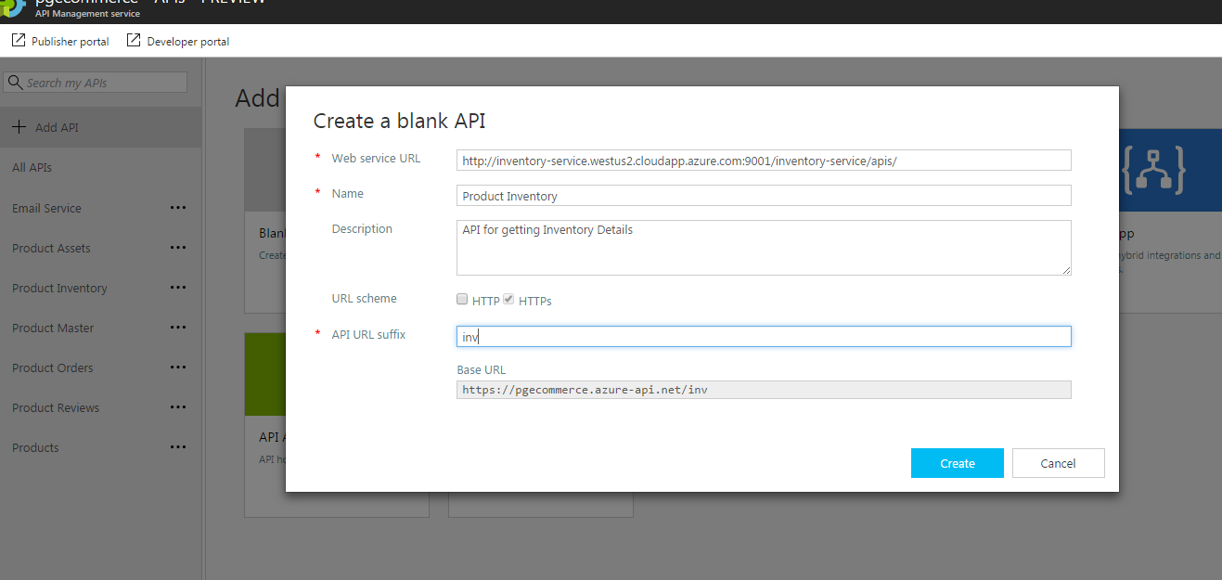

1. Once its created you can see it in left navigation bar, click on it and add required operations which you need , it will look like this after that is done

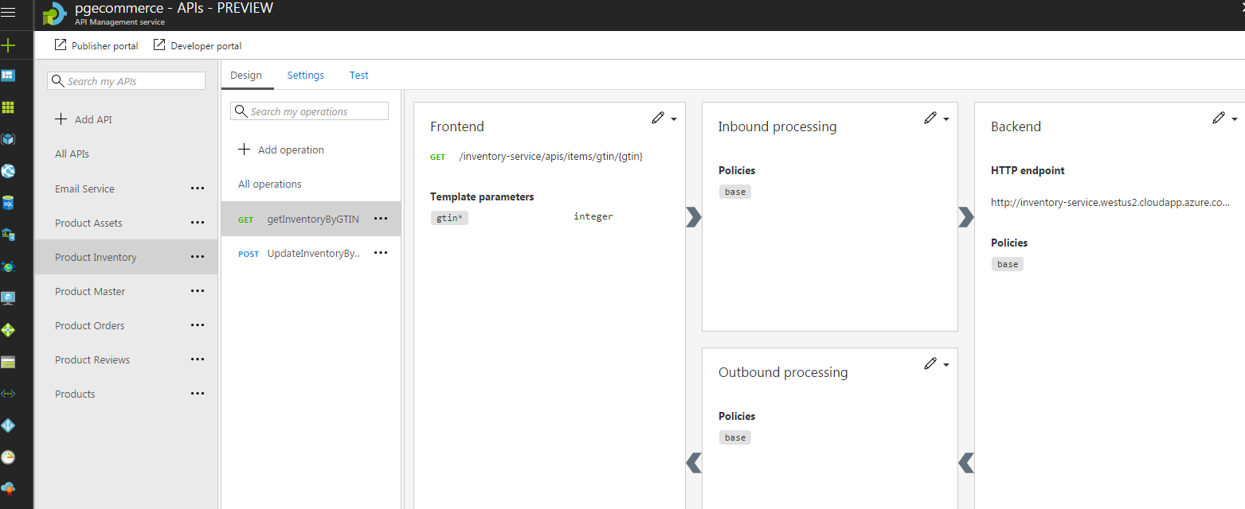

1. Add the API to product in order to allow authorization while hitting API like given below

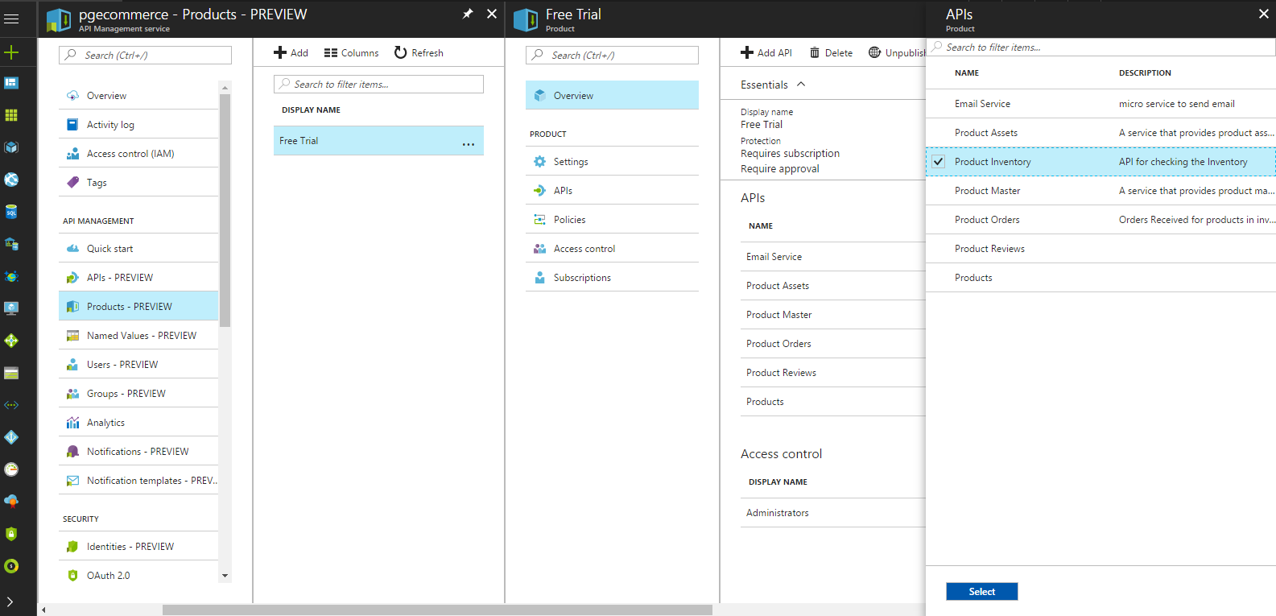

1. It will look like this once you add your APIs there ,

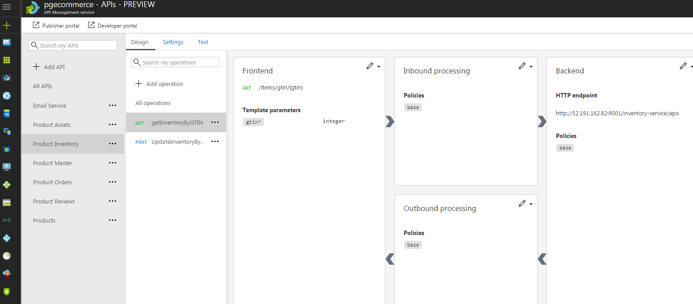

1. You can access the get API on this link

[https://pgecommerce.azure-api.net/inv/items/gtin/{gtin}](https://pgecommerce.azure-api.net/inv/items/gtin/%7bgtin%7d) -getItemsbyGtin

https://pgecommerce.azure-api.net/inv/ items/{gtin}/order – updateInventoryByOrder

path variable : gtin

queryParam : orderId, orderQty